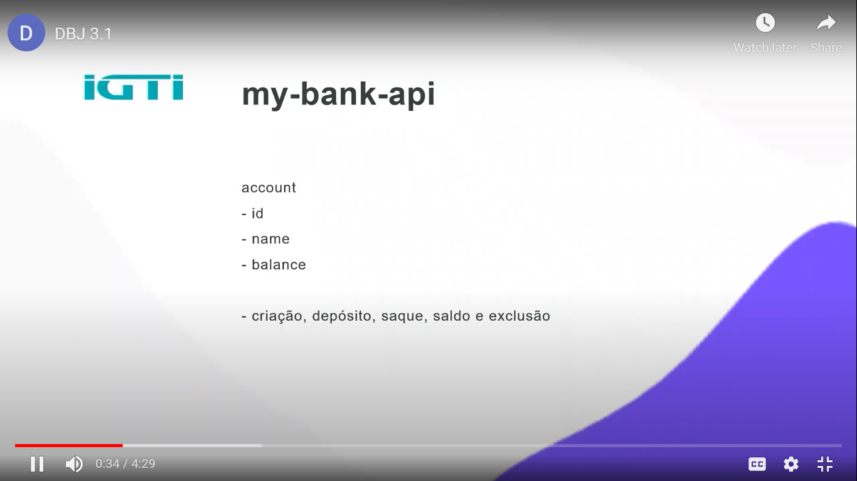
https://www.youtube.com/watch?v=byTOP7MAe6U

https://www.youtube.com/watch?v=jMafMwbVmXk

https://www.youtube.com/watch?v=weXIXR9Ob_c

https://www.youtube.com/watch?v=4dj1q9t_dIs

https://www.youtube.com/watch?v=MIWUN2lXxuY

https://www.youtube.com/watch?v=qf7pOw9s0WA

